Year 11

Course Expectations

Winchmore School

2022-2024



Dear Parents / Carers of Students in Year 11

This Course Expectations booklet provides you and your child with information about the courses they are studying in Key Stage 4 from 2022 to 2024. It provides information for each subject about the course structure and resources for how you can support your child.

It also contains information about the grading for new GCSEs from 2017. As you may be aware the GCSE grading and content for most subjects has been changed. These subjects use the new grading system from 9 to 1;

* Art and Graphic Art
* Business – GCSE
* Computing
* Dance
* Drama
* English Language and Literature
* Geography
* History
* Mathematics
* Media Studies
* Modern Foreign Languages – French, Spanish, Turkish and Community Languages
* Music
* PE – GCSE
* Photography
* Religious Studies
* Science – Combined Science and separate Biology, Chemistry and Physics
* Sociology
* Textiles

Other subjects use the ‘Pass, Merit, Distinction, Distinction*’ grading system, which are equivalent to the old C-A* grades.

We have enclosed a comparison from Ofqual which illustrates the grading for GCSEs from 2017 and more information about GCSEs is available on the school website in the KS4 section under Curriculum.

Thank you for your support.

Yours faithfully

  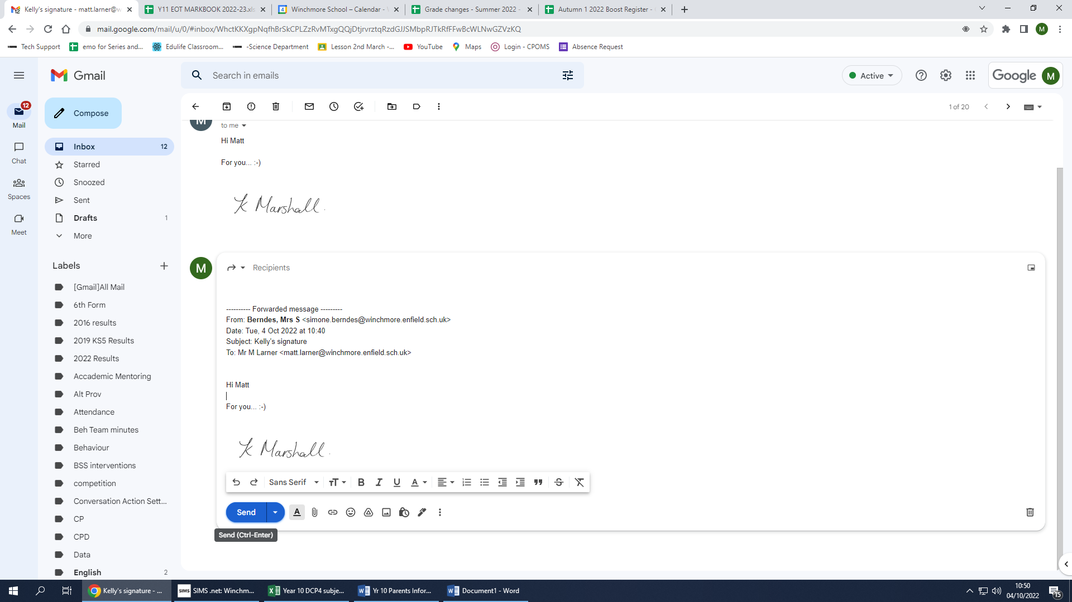

Mr M Larner Mrs Marshall

Assistant Headteacher KS4 Head of Year 11

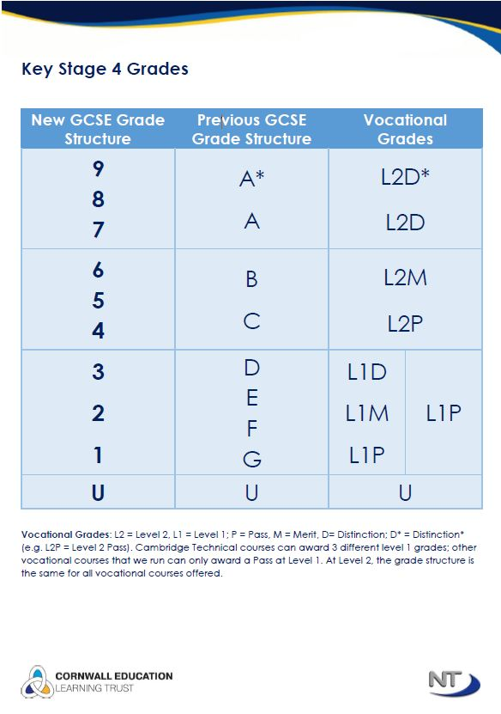

Key;

L2D* - Level 2 Distinction *

L2D – Level 2 Distinction

L2M – Level 2 Merit

L2P – Level 2 Pass

L1D – Level 1 Distinction

L1M – Level 1 Merit

L1P – Level 1 Pass

**HELPING YOUR CHILD THROUGH EXAMS**

**Subject information sheets**

|  |  |  |  |  |  |  |  |  |  |  |  |  |  |  |  |
| --- | --- | --- | --- | --- | --- | --- | --- | --- | --- | --- | --- | --- | --- | --- | --- |
| **Subject** | | | **Exam Board** | | | **Structure and Method of Assessment** | | | | | | | | | **Notes/Useful Resources** |
| **Examinations** | | | | | **Non-Examination Assessment (NEA)** | | | |
| **English Language** | | | AQA | | | **Paper 1:** Explorations in Creative Reading and Writing   * 1 hr 45 mins * 50% of GCSE   **Paper 2**: Writers’ Viewpoints and Perspectives   * 1 hr 45 minutes * 50% of GCSE | | | | | **Spoken Language**   * Separate endorsement * Compulsory * 0% weighting of GCSE | | | | * **These are two separate GCSES and are taught throughout the academic year** * Students are given a homework booklet for each unit taught and are expected to complete 1 hour of English homework a week * Students have a login to access the following revision apps: PIXL and GCSE pod * Useful revision websites include:   [GCSE - BBC Bitesize](https://www.bbc.co.uk/bitesize/levels/z98jmp3)  [Mr Bruff - YouTube](https://www.youtube.com/user/mrbruff)  [Free Homework & Revision for A Level, GCSE, KS3 & KS2 (senecalearning.com)](https://senecalearning.com/en-GB/)   * All assessments are closed book: any stimulus materials required will be provided as part of the assessment * Students are expected to buy copies of all texts being studied * Details of the specifications can be found at:  [www.aqa.org.uk/subjects/english](http://www.aqa.org.uk/subjects/english) |
| **Subject** | | | **Exam Board** | | | **Structure and Method of Assessment** | | | | | | | | |
| **Examinations** | | | | | **Non-Examination Assessment (NEA)** | | | |
| **English Literature** | | | AQA | | | **Paper 1:** Shakespeare and the 19th Century Novel   * 1 hr 45 minutes * 50% of GSCE   **Paper 2:** Modern Texts and Poetry   * 2 hrs 15 minutes * 50% of GCSE | | | | | N/A | | | |
| **Subject** | | **Exam Board** | | | **Structure and Method of Assessment** | | | | | | | **Notes/Useful Resources** | | | |
| **Examinations** | | | **Non-Examination Assessment (NEA)** | | | |
| **Mathematics** | | Edexcel | | | **Paper 1 : Non Calculator**   * 80 Marks * 1hr 30 minutes * 33.33% of GCSE   **Paper 2:** Calculator Allowed   * 80 Marks * 1hr 30 minutes * 33.33% of GCSE   **Paper 3:** Calculator Allowed   * 80 Marks * 1hr 30 minutes * 33.33% of GCSE | | | N/A | | | | * Students will be entered for Higher or Foundation Tier * Scientific calculator (which is not programmable or that can do algebra) and a geometry set. * Students expected to complete 1½ hours of Maths homework every week. * Useful Websites:   <http://www.bbc.co.uk/schools/gcsebitesize>  [http://www.emaths.co.uk](http://www.emaths.co.uk/)  [http://www.emaths.org](http://www.emaths.org/)  http://[www.mymaths.co.uk](http://www.mymaths.co.uk)  [http://www.gcsemathspastpapers.com](http://www.gcsemathspastpapers.com/)  [http://ngfl.gov.org](http://ngfl.gov.org/)   * + Students have a login to access a Maths APP for revision in Year 11 [*https://mathsapp.pixl.org.uk/*](https://mathsapp.pixl.org.uk/) * Edexcel GCSE Mathematics A Linear Higher or Foundation course from Collins. Textbooks are used. The relevant book depends on tier on entry. All of the books can be ordered at any good book shops. * Edexcel GCSE Maths Foundation ISBN 978-0-19-835150-4 * Edexcel GCSE Maths Higher ISBN 978-0-19-835151-1 | | | |
| **Subject** | **Exam Board** | | | **Structure and Method of Assessment** | | | | | | | | | **Notes/Useful Resources** | | |
| **Examinations** | | | | | **Non-Examination Assessment (NEA)** | | | |
| **Combined Science** | AQA | | | **Combined Trilogy**  **Biology Paper 1:**   * 70 Marks * 1hr 15 minutes * 16.7% of GCSE   **Chemistry Paper 1:**   * 70 Marks * 1hr 15 minutes * 16.7% of GCSE   **Physics Paper 1:**   * 70 Marks * 1hr 15 minutes * 16.7% of GCSE | | | **(Worth 2 GCSES)**  **Biology Paper 2:**   * 70 Marks * 1hr 15 minutes * 16.7% of GCSE   **Chemistry Paper 2:**   * 70 Marks * 1hr 15 minutes * 16.7% of GCSE   **Physics Paper 2:**   * 70 Marks * 1hr 15 minutes * 16.7% of GCSE | | N/A | | | | * The majority of students will study this Science course for GCSE * Students will be entered for Higher or Foundation Tier * A GCSE Revision Guide can be purchased from Parent Pay for £13 * Revision flash cards re available via ParentPay for £11 * [Resources](http://www.cambridgegcsecomputing.org/) are available via the science revision Kerboodle page (institution code yq4) * Revision tests available on [www.educake.co.uk](http://www.educake.co.uk) * Details of the specifications can be found at: https://www.aqa.org.uk/subjects/science/gcse/combined-science-trilogy-8464 | | |
|  | | | | |
|  | | |  | | |  | | | | | | | |  | |
| **Subject** | **Exam Board** | | | **Structure and Method of Assessment** | | | | | | | | | **Notes/Useful Resources** | | |
| **Examinations** | | | | | **Non-Examination Assessment (NEA)** | | | |
| **Separate Sciences (Biology, Chemistry and Physics)** | AQA | | | **Separate Sciences**  **Biology Paper 1:**   * 100 Marks * 1hr 45 minutes * 16.7% of GCSE   **Chemistry Paper 1:**   * 100 Marks * 1hr 45 minutes * 16.7% of GCSE   **Physics Paper 1:**   * 100 Marks * 1hr 45 minutes * 16.7% of GCSE | | | **(Worth 3 GCSES)**  **Biology Paper 2:**   * 100 Marks * 1hr 45 minutes * 16.7% of GCSE   **Chemistry Paper 2:**   * 100 Marks * 1hr 45 minutes * 16.7% of GCSE   **Physics Paper 2:**   * 100 Marks * 1hr 45 minutes * 16.7% of GCSE | | N/A | | | | * Students will only take this Science course if they were Mastering in Year 9 and asked to take it as part of the Option process. * Students will be entered for Higher or Foundation Tier * A GCSE Revision Guide can be purchased from Parent Pay for £13 * Revision flash cards re available via ParentPay for £11 * [Resources](http://www.cambridgegcsecomputing.org/) are available via the science revision Kerboodle page (institution code yq4) * Revision tests available on [www.educake.co.uk](http://www.educake.co.uk) * Details of the 3 specifications can be found at: http://www.aqa.org.uk/subjects/science/gcse | | |
| **Subject** | | | **Exam Board** | | | **Structure and Method of Assessment** | | | | | | | | **Notes/Useful Resources** | |
| **Examinations** | | | | **Non-Examination Assessment (NEA)** | | | |
| **Art, Craft & Design and Graphic Communication**  (GCSE Art and GCSE Digital Art) | | | EDEXCEL | | | **Component 2 : Externally Set Assignment**   * 10 hour exam * 40% of GCSE * The exhibition set up day (beginning of June) is the deadline. Exam and non-examined assessment will be returned to display. Internal and external moderation will occur in early June. | | | | **Component 1: Personal Portfolio in Art and Design**   * 60% of GCSE | | | | * Your child will have a clear project brief with individual tasks and deadlines for Component 1 and 2. Their teacher will also give them clear guidelines on how to improve their work to gain higher marks. * Pupils will be expected to complete homework and attend art clubs at lunch or after school. * The teachers will keep you updated on their progress and contact you with any concerns. | |

|  |  |  |  |  |
| --- | --- | --- | --- | --- |
| **Subject** | **Exam Board** | **Structure and Method of Assessment** | | **Notes/Useful Resources** |
| **Examinations** | **Non-Examination Assessment (NEA)** |
| **Computer Science** | OCR | **Paper 1 : Computer Systems**   * 80 Marks * 1hr 30 minutes * 50% of GCSE   **Paper 2:** Computational Thinking, Algorithms and Programming   * 80 Marks * 1hr 30 minutes * 50% of GCSE | **Programming Project**   * 20 hours completed in lessons | * Revision books available via parent pay for £2 * Revision resources available via Google Classroom * Students are encouraged to download python from this   [www.python.org](http://www.python.org) to help practice their python skills |

|  |  |  |  |  |  |  |  |  |
| --- | --- | --- | --- | --- | --- | --- | --- | --- |
| **Subject** | | **Exam Board** | **Structure and Method of Assessment** | | | **Notes/Useful Resources** | | |
| **Examinations** | **Non-Examination Assessment (NEA)** | |
| **GCSE Business Studies** | | Edexcel | **Theme 1:** Investigating small business   * 90 marks * 50% of final grade * 90 mins   **Theme 2:** Building a business   * 90 marks * 50% of final grade * 90 mins |  | | * Your child will be supported in lesson with past exam papers and exam questions to prepare them for the exams they will face at the end of year 11. * Textbooks issued to each students at the beginning of year 10 which they will need for the two year course. * Digital version of textbooks are accessible online: http://www.businessed.co.uk/index.php/home/activities/gcse-activities/edexcel-gcse-activities * Activities and key term resources are accessible at: <Http://www.businessstudiesonline.co.uk/gcsebusiness/activities/activitymenu.htm> | | |
| **NCFE Business** | | NCFE | **Unit 1 :**  Understanding Business and Enterprise .  80 mark external  assessment   * 40% of the technical award * 1 hour 30 minutes | **Unit 2:**  Understanding resources for Business and Enterprise planning  60% of the technical award.  The completion time for the non-exam assessment is **21 hours** of supervised time  Assessed through synoptic project completed under invigilation. | | * Learners must complete 2 mandatory units. * This course is awarded using the Pass, Merit and Distinction grading. * Students will have 1 attempt to Pass the External Unit. If they do not pass the Exam, they will not be able to get a grade on the course. | | |
| **Subject** | **Exam Board** | | **Structure and Method of Assessment** | | | | **Notes/Useful Resources** |
| **Examinations** | | **Non-Examination Assessment (NEA)** | |
| **Dance** | AQA | | **Component 2:** Dance Appreciation   * 80 Marks * 1hr 30 minutes * 40% of GCSE | | **Component 1:** Performance and Choreography  **Performance**   * 30% of GCSE * Set phrases through a solo performance (approximately one minute in duration) * Duet/trio performance (three minutes in a dance which is a maximum of five minutes in duration)   **Choreography**   * 30% of GCSE * Solo or group choreography – a solo (two to two and a half minutes) or a group dance for two to five dancers (three to three and a half minutes) | | * Past Papers and Revision Material available through the department. * Dance Library located in Dance Studio 2 and School Library * Regularly check dance folders * Attend dance opportunities/trips on offer throughout the year. * Workshops and revision guides are available through the department/parent pay at a small cost. |

|  |  |  |  |  |
| --- | --- | --- | --- | --- |
| **Subject** | **Exam Board** | **Structure and Method of Assessment** | | **Notes/Useful Resources** |
| **Examinations** | **Non-Examination Assessment (NEA)** |
| **Drama** | Edexcel | **Component 2:** Performance from text   * Externally assessed - Perform two key extracts from a performance text * Worth 20% of GCSE   **Component 3:** Theatre Makers in Practice   * 60 Marks * 1hr 30 minutes * 40% of GCSE | **Component 1:** Devising   * Internally assessed - 1 unique and independently created piece of original theatre / actors portfolio * Worth 40% of GCSE | * Key terminology and theory can be revised from their logbooks or at: <http://www.bbc.co.uk/education/subjects/zbckjxs> * Students can purchase an exam board revision guide from Amazon (Course title is Drama Edexcel GCSE 9-1) * Students identified for support with dramatic theory and practice, are asked to attend revision sessions after school on a Wednesday in drama 1. Letters will be sent home to inform parents * All written work must be completed and submitted in electronic format. |
| **Vocational Award Performing Arts (Acting)** | WJEC | **Unit 3:** **Performing Arts in Practice** 20hrs controlled assessment. Candidates will undertake a series of set tasks that are to be applied to a prescribed context set by WJEC  40% of the qualification | **Unit 1: Performing**  Responding to a brief set by the exam board. Students will perform a published script that meets the brief.  30% of the qualification  **Unit 2: Creating**  Responding to a brief set by the exam board. Students will create an original piece that meets the brief.  30% of the qualification | * Students identified for support with dramatic theory and practice. Letters will be sent home to inform parents * All written work must be completed and submitted in electronic format. * Students will have the opportunity to visit professional theaters/creative spaces. |

|  |  |  |  |  |
| --- | --- | --- | --- | --- |
| **Subject** | **Exam Board** | **Structure and Method of Assessment** | | **Notes/Useful Resources** |
| **Examinations** | **Non-Examination Assessment (NEA)** |
| **WJEC Level 1/2 Hospitality and catering** | WJEC | * Unit 1- Exam paper  |  | | --- | | The Hospitality and Catering Industry   * 40% of final grade   1hr 30 minutes length exam (students have two attempts) | | Hospitality and Catering in Action   * Unit 2- Controlled assessment to be completed in 9 hours   This will be completed in year 11  60% of final grade | * All written work must be completed and submitted in electronic form * Students will need to bring in ingredients for all practical lessons. Missing practicals will affect their grade. * WJEC Level 1/2 Hospitality and catering revision book purchased on amazon |

|  |  |  |  |  |
| --- | --- | --- | --- | --- |
| **Subject** | **Exam Board** | **Structure and Method of Assessment** | | **Notes/Useful Resources** |
| **Examinations** | **Non-Examination Assessment (NEA)** |
| **Geography** | Eduqas | * **Component 1:** Investigating Geographical Issues * 1hr 45 minutes * 40% of GCSE   **Component 2:** Problem Solving Geography   * 1hr 30 minutes * 30% of GCSE   **Component 3**: Applied Fieldwork Enquiry Written exam worth 30% (1 hour 30 minutes)   * 1hr 30 minutes * 30% of GCSE | * N/A | Encourage your child to use the websites listed below:   * [*http://www.doddlelearn.co.uk*](http://www.doddlelearn.co.uk) * [*http://www.bbc.co.uk/schools/gcsebitesize/geography*](http://www.bbc.co.uk/schools/gcsebitesize/geography/) * [*https://geographyapp.pixl.org.uk/*](https://geographyapp.pixl.org.uk/) * [*http://www.bbc.co.uk/education/subjects/zkw76sg*](http://www.bbc.co.uk/education/subjects/zkw76sg) * GCSEPod * Revision material will be given out in class, but additional GCSE Revision Guides for Eduqas B GCSE Geography can be purchased in shops or online. * All students should attend fieldwork. A field trip to Norfolk is currently planned for the start of year 11. |

|  |  |  |  |  |
| --- | --- | --- | --- | --- |
| **Subject** | **Exam Board** | **Structure and Method of Assessment** | | **Notes/Useful Resources** |
| **Examinations** | **Non-Examination Assessment (NEA)** |
| **History** | AQA | **Paper 1: Understanding the modern world**  Section A Period studies [*1B Germany, 1890–1945: Democracy and dictatorship*]  Section B Wider world depth studies [*Conflict and tension between East and West, 1945–1972*]:   * 84 Marks * 2 hours * 50% of GCSE   **Paper 2: Shaping the nation**  Section A: Thematic studies [*2A Britain: Health and the people: c1000 to the present day]:*  Section B: British depth studies including the historic environment [*Elizabethan England, c1568–1603*]:   * 84 Marks * 2 hours * 50% of GCSE | N/A | * Encourage your child to use the websites listed below: * [www.GCSEPod.com](http://www.GCSEPod.com) * <http://www.bbc.co.uk/education/subjects/zj26n39> * Revision material will be given out in class, but additional GCSE Revision Guides can be purchased from Amazon * Oxford AQA GCSE History (9-1): Germany, 1890-1945: Democracy and Dictatorship revision guide * Oxford AQA GCSE History (9-1): Conflict and tension between East and West, 1945-1972 revision guide * Oxford AQA GCSE History (9-1): Health and the people, c.1000 to the present day revision guide * Oxford AQA GCSE History (9-1): Elizabethan England, c.1568-1603 revision guide |

|  |  |  |  |  |
| --- | --- | --- | --- | --- |
| **Subject** | **Exam Board** | **Structure and Method of Assessment** | | **Notes/Useful Resources** |
| **Examinations** | **Non-Examination Assessment (NEA)** |
| **Health and Social Care** | OCR | **RO32:**  Principles of care in health and social care settings  65 min external exam taken in February or May of Year 11.  Worth 40% of GCSE | **RO33**: Supporting individuals through life events  Worth 30% of GCSE    **RO35:** Health promotion campaigns  Worth 30% of GCSE | * All students have access to the course textbook for the duration of the course during lesson time. * Hodder My Revision Notes- Health and Social Care Revision Guide, is available from Amazon ISBN: 978-1398351240 * Past Papers and Revision Materials available on student's subject-specific Google Classroom * Course graded: Pass, Merit, Distinction, Distinction* |

|  |  |  |  |  |
| --- | --- | --- | --- | --- |
| **Subject** | **Exam Board** | **Structure and Method of Assessment** | | **Notes/Useful Resources** |
| **Examinations** | **Non-Examination Assessment (NEA)** |
| **NCFE**  **Interactive Media** | NCFE | **Unit 1 :** Features of Interactive multimedia products   * 80 Marks * 1hr 30 minutes * 40% of GCSE | **Unit 2 :** Interactive Media   * Worth 60% of the course * 120 Marks * Completion time 17 hours | * Learners must complete 2 mandatory units. * Past Papers and Revision Material available through Google classroom * Course is Grade Pass/Merit/Distinction |

|  |  |  |  |  |
| --- | --- | --- | --- | --- |
| **Subject** | **Exam Board** | **Structure and Method of Assessment** | | **Notes/Useful Resources** |
| **Examinations** | **Non-Examination Assessment (NEA)** |
| **Media Studies** | WJEC/  Eduqas | **Paper 1: Exploring the Media**   * 1hr 30 mins * Worth 40% of GCSE   **Paper 2: Understanding Media**  **Forms and Products**   * 1hr 30 mins * Worth 30% of GCSE | **Externally Marked NEA**   * Worth 30% of GCSE   Students have to respond to a set brief from the exam board which changes every year. This work usually consists of a front page and contents page for a new magazine aimed at teenagers which has to use original images throughout. | * Regular after school support sessions offered to complete N0n-Examinantion Assessment work. * Revision guides are available to purchase from your teacher. |

|  |  |  |  |  |
| --- | --- | --- | --- | --- |
| **Subject** | **Exam Board** | **Structure and Method of Assessment** | | **Notes/Useful Resources** |
| **Examinations** | **Non-Examination Assessment (NEA)** |
| **MFL**  **French and Spanish**  **Turkish**  **Community Languages** | AQA  EDEXCEL | **Unit 1 [Listening]:** Exam worth 25%  **Unit 2 [Speaking]**: Exam worth 25%  **Unit 3 [Reading]:** Exam worth 25%  **Unit 4 [Writing]**: Exam worth 25% | N/A | * Students will be entered of either the Foundation or Higher Tier papers * [www.linguascope.co.uk](http://www.linguascope.co.uk) * [www.memrise.co.uk](http://www.memrise.co.uk) * [www.quizlet.com](http://www.quizlet.com) * <https://www.languagenut.com/en-gb/> (please request details from your teacher if unsure about log in details) * Past Papers and Revision Material available through student’s Google Classroom |
| **Subject** | **Exam Board** | **Structure and Method of Assessment** | | **Notes/Useful Resources** |
| **Examinations** | **Non-Examination Assessment (NEA)** |
| **Music** | Edexcel | **Component 3:** Appraising Music   * 80 Marks * 1 hr 45 minutes * Worth 40% of GCSE * 9 Questions | **Component 1:** Performing Music   * A solo and ensemble performance * Worth 30% of GCSE   **Component 2:** Composing Music   * Two compositions * Worth 30% of GCSE | * Download Spotify and set up a free account for your child * Keep track of your child’s PERI lesson planner and ensure they attend all lessons. Support their practice at home * <https://www.musictheory.net/> |
| **Subject** | **Exam Board** | **Structure and Method of Assessment** | | **Notes/Useful Resources** | |
| **Examinations** | **Non-Examination Assessment (NEA)** |  |
| **BTEC L1/L2 Music Practice** | Pearson | **Component 3**  - Responding to a Music Brief   * Externally examined coursework * Synoptic Project * Worth 40% of qualification * Composition task to a brief. * Completed in Year 11 | **Component 1** - Popular Styles and Music Products   * Internally marked coursework * Completed in Year 10 * Worth 30% of qualification   **Component 2** - Music Skills Development   * Internally marked coursework * Completed in Year 11 * Worth 30% of qualification | * Download Spotify and set up a free account for your child * Keep track of your child’s PERI lesson planner and ensure they attend all lessons. Support their practice at home * <https://www.musictheory.net/> * <https://www.youtube.com/user/MusicTechHelpGuy> |

|  |  |  |  |  |
| --- | --- | --- | --- | --- |
| **Subject** | **Exam Board** | **Structure and Method of Assessment** | | **Notes/Useful Resources** |
| **Examinations** | **Non-Examination Assessment (NEA)** |
| **GCSE**  **PE** | AQA | Paper 1: The human body and movement in physical activity and sport  Written exam: 1 hour 15 minutes  • 78 marks   • 30% of GCSE  Paper 2: Socio- Cultural influences and well-being in physical activity and sport   Written exam: 1 hour 15 minutes  • 78 marks  • 30% of GCSE | Assessed by teachers. Moderated by AQA  • 100 marks  • 40% of GCSE  Practical performance in three different physical activities in the role of player/performer (one in a team activity, one in an individual activity and a third in either a team or in an individual activity).   For each of their three activities, students will be assessed in skills in progressive drills (10 marks per activity) and in the full context (15 marks per activity).  Students will be assessed on their analysis (15 marks) and evaluation (10 marks) of performance to bring about improvement in one activity | * Resources available at: * <https://www.aqa.org.uk/subjects/physical-education> * GCSEpod.com * <https://www.bbc.co.uk/bitesize/guides> * Revision material will be given out in class, but additional GCSE Revision Guides can be purchased in shops or online. |
| **Subject** | **Exam Board** | **Structure and Method of Assessment** | | **Notes/Useful Resources** | |
| **Examinations** | **Non-Examination Assessment (NEA)** |  |
| **NCFE**  **PE** | NCFE | Unit 1 Introduction to the body systems and principles of training  40% of final grade  1 hour 30 minutes | Unit 2 Preparing and planning for health and fitness  60% of final grade, assessed through portfolio | * Resources available at : * <https://www.ncfe.org.uk> * This course has a large biology content and is 100% classroom based. |

|  |  |  |  |  |
| --- | --- | --- | --- | --- |
| **Subject** | **Exam Board** | **Structure and Method of Assessment** | | **Notes/Useful Resources** |
| **Component 1** | **Component 2** |
| **Photography** | Edexcel | **Project 1** - **The School of Photography**  Each student will enrol onto The School of Photography beginner’s course. This is a online course which provides Students with all the learning material necessary to learn how to use your camera and take full control of all its settings.  **Project 2- ‘Destroyed’ Selfie Project Spring Term**  This project will focus on the subject of portraiture. Students will research a variety of Photographers and analyse their work and how they have created it to develop their own ideas in support of a final outcome. | **Exam Project - Externally set assignment by the exam board**  Students will complete an exam brief which has been set by the exam board. Students will complete a series of tasks linked to photographers’ research before exploring, experimenting and developing a final outcome. Students will sit a 10 hour timed exam where they will be required to complete a final piece in response to the exam theme. | * GCSE Student Handbook is given to all students on the course. * The School of Photography – Student Log In [www.theschoolofphotography.com](http://www.theschoolofphotography.com) * www.youtube.com/c/theschoolofphotography * <http://www.bbc.co.uk/schools/gcsebitesize/art/> * <http://www.pinterest.com/> * <http://photofocus.com/> * <https://www.flickr.com> * <http://expertphotography.com/> * <https://www.britishphotographyawards.org> * <https://www.photoawards.com> |

|  |  |  |  |  |  |  |
| --- | --- | --- | --- | --- | --- | --- |
| **Subject** | **Exam Board** | **Structure and Method of Assessment** | | | | **Notes/Useful Resources** |
| **Examinations** | **Non-Examination Assessment (NEA)** | | |
| **Product Design** | WJEC | **Unit 2**: Externally Set Assignment  40% of qualification: 80 marks  Part 1: Preparatory study period  Part 2: 10 hour period of sustained focus work | **Unit 1**: Portfolio  60% of qualification: 120 marks | | | * Encourage your child to use the websites listed below: * <https://www.technologystudent.com/> * <https://www.bbc.co.uk/bitesize/subjects/zvg4d2p> * <https://www.wjec.co.uk/qualifications/art-and-design-gcse/#tab_overview> * GCSE Revision Guides can be purchased in shops or online. |
|  |  |  | | |  | |
| **Subject** | **Exam Board** | **Structure and Method of Assessment** | | | | **Notes/Useful Resources** |
| **Examinations** | **Non-Examination Assessment (NEA)** | | |
| **RE** | AQA | **Paper 1:** The study of Religions: beliefs, teachings and practices   * 96 Marks (plus 6 for spelling punctuation and grammar) * 1 hr 45 minutes * Worth 50% of GCSE   **Paper 2: Thematic Study**   * 96 Marks (plus 3 for spelling punctuation and grammar) * 1 hr 45 minutes * Worth 50% of GCSE | N/A | | | * Encourage your child to use the websites listed below: * <http://www.doddlelearn.co.uk> * <https://www.youtube.com/results?search_query=bbc+teach+religious+studies> * <https://www.bbc.co.uk/bitesize/subjects/zmyb4wx> * <https://www.aqa.org.uk/subjects/religious-studies/gcse/religious-studies-a-8062> * Revision material will be given out in class, and is available on Parent Pay * GCSEPod |
| **Subject** | **Exam Board** | **Structure and Method of Assessment** | | | | **Notes/Useful Resources** |
| **Examinations** | | **Non-Examination Assessment (NEA)** | |
| **Sociology** | EDUQAS | 100% Examination   * Each component will cover a mixture of short answer, structured questions and extended responses which are all compulsory.   Component 1: Understanding Social Processes  100 marks  1 hour 45 minutes  Topics:   * Key concepts and processes of cultural transmission * Families * Education * Sociological research methods   Component 2:  Understanding Social structures  100 marks  1 hour 45 minutes   * Social differentiation and stratification * Crime and deviance * Applied methods of sociological enquiry | |  | | Please can you support your child by using/directing them towards:   * The booklets that have been handed out in class to test their knowledge of key terminology and sociologists. * <https://www.bbc.co.uk/bitesize/subjects/zbbw2hv> * Google Classroom * <http://www.gojimo.com/gcse-sociology-revision/> * <https://quizlet.com/subject/eduqas-gcse-sociology/> * GCSEPod |

|  |  |  |  |  |
| --- | --- | --- | --- | --- |
| **Subject** | **Exam Board** | **Structure and Method of Assessment** | | **Notes/Useful Resources** |
| **Examinations** | **Non-Examination Assessment (NEA)** |
| **Textiles** | WJEC | **Unit 2**: Externally Set Assignment   * 40% of qualification: 80 marks   Part 1: Preparatory study period  Part 2: 10 hour period of sustained focus work  Students will work towards producing a final piece of textiles work within the set 10 hours framework | **Component 1:** Personal Portfolio  Worth 60% of GCSE  Students will work on different projects to build their skills and develop their knowledge and understanding of artists, textiles designers, textiles techniques and construction methods. Students will also learn to explain their ideas, analyse, and evaluate their decisions throughout their projects. | * Useful websites: * <https://www.vam.ac.uk/> * <http://www.tate.org.uk/visit/tate-modern> * <http://www.vogue.com/fashion-shows> * Your child will have 3 project briefs set during year 10 with a mock exam at the end of the year. In the projects, students will be set individual tasks and homework. * In year 11, there will be another project with a mock exam in the first term, followed by the exam criteria for the final project and exam. * Pupils will be expected to complete homework and attend Textile clubs after school. * The teachers will keep you updated on their progress and contact you with any concerns. * If you have a sewing machine at home, any practice you can give your child will help their overall progress on the course. * Homework is set in sketchbooks. Students are expected to keep them up to date in their own time. |